Local Services Directory
(Version 07/2018)
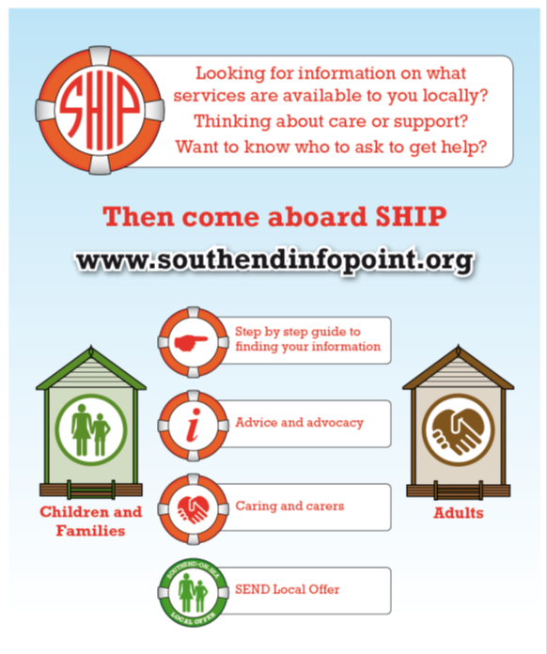
To find services locally search on Southend Information Point www.southendinfopoint.org
Contents
Advice, information, housing and finances 1
Advocacy 2
Befriending and loneliness 3
Handyman and gardening 4
Transport 4
Meal deliveries and shopping 4
Health and exercises 5
Socialising and activities 5
Volunteering 5
Safety 6
Emergency food and funds 6
Homelessness 7
Mental Health/bereavement 7
Substance misuse 7
Sight and hearing loss 8
Mobile services/home visits 8
Charitable Grants and help with costs 8
Pets and animals 9
Organising own care 9
Public services numbers 9

Feedback

Please email adult-redesign@southend.gov.uk with comments so we can keep making next versions more useful for you.

Advice, information, housing and finances

Citizens Advice Bureau 0344 477 0808
Debt advice, help with filling in forms, appeals, benefits and legal advice, home visits available if disabled
Age Concern 01702 345373
Over 60’s, local providers’ directory, volunteer drivers, tea club
Dementia Community Support Service 01702 534772
For adults with dementia and their carers, advice and education, support, peer groups
Southend Carers 01702 393933
For informal carers, training, counselling, ad-hoc respite, emergency respite scheme, one off practical support, peer groups set up around Southend.
Community Hubs 01702 469212
Southend Victoria Shopping Centre/Shoeburyness, SS3 9EF. Housing and benefits advice, IT skills, English as second language courses, volunteering
West Leigh Baptist Church Community Hub 01702 472100
Variety of services and community groups
Age Concern Community Hub 01702345373
Drop in with social worker, dementia navigator
Family Mosaic 0800 288 8883 / 01702 445870
Housing related support, help with benefits and accessing services, debt advice, drop in centres and home visits for housebound adults
Mencap Southend 01702 334514
Information, advice and advocacy for families and people with learning disabilities
LEAP – Local Energy Advice Programme 0800 060 7567
FREE service, providing important advice, support and energy saving measures to fuel poor and vulnerable households. Income/benefits maximisation. Help with grants.

Advocacy

POhWER 0300 456 2370
Care Act advocacy services, Community Advocacy, Independent Mental Capacity Advocates
South Essex Advocacy for Older People 01702 340566
Over 60 - advocacy, help with filling in forms and support in accessing housing, dealing with debt
Healthwatch Southend 01702 416320
Information and advice on health and social care, advocacy and complaints

Befriending and loneliness

Age Concern 01702 345373
Over 60’s befriending in person and on the phone, but can also accommodate younger adults with disabilities if they need support and the charity is able to find a matching volunteer.
Folk Like Us - Turning Tides 01702 356070
Provides support and advice to people over the age of 65, living in the borough of
Southend who are experiencing loneliness and isolation, drop in centre or visit, main aim is to connect the person with their community
Saint Vincent De Paul Society Southend 07702925192 (local contact Pete Wake)
Home visits for lonely people
The Silver Line – 0800 470 8090
Telephone befriending and volunteering opportunities
Age UK 0800 678 1174
Telephone befriending and volunteering opportunities
SSAFA Southend 01702 463113
Armed forces charity for former and current service man and their families, support, advice, grants. National Service counts towards eligibility. Local drop in and social club.

Cleaning and shopping services

Age UK Essex Home Help Service 01245 207 029
(previously known as CAPE, hourly rate), vetted. £13.5hr
Green Clean Westcliff 07941 441238
Cleaning and small errands, DBS, £10.5hr
One Response Cleaning 07525243798
Deep clean, moving, regular cleaning £12.5hr
SOS Cleaning 07796 173741
Deep cleans

Handyman and gardening

Age Concern handyman 01702 345373
60+, Volunteer will assess if they can complete the job
Handyperson Service 01702 215511
£17 an hour, “at the discretion of our office, we may carry out preventative works free of charge - as part of our slips, trips and falls programme.”
All Seasons Gardening 01268 638406
£17.5/hr

Transport

Age Concern 01702 345373
Over 60 Volunteer drivers - pay for mileage, bus for trips.
Access Anyone 01702 524584
Wheelchair taxi, wheelchair minibus, private ambulance. Escort can go with adult, book in advance
Care Cars 01702 385125
Southend Hospital voluntary transport scheme. Donation requested to cover driver's costs. Seven days’ notice needed.

Meal deliveries and shopping

Hot meals deliveries:
Glenwood Cafe 01702 341558
Direct2U 07787556663
Frozen meals deliveries:
Wiltshire Farm Foods 0800 077 3100/ 01268 288 887
Oakhouse 0845 643 2009 (plus groceries and toiletries)
Shopping:
Milk and More 0345 606 3606
Milk, groceries, veg, fruit and toiletries delivered to the door, pay online/on the phone, order on the phone
NF Collins and Son Dairies 01268 777497
Milk, groceries and toiletries delivered to the door, order on the phone
Byfords Food Hall 01702 525903
Local shop in Leigh on Sea, deliveries

Health and exercises

Life Style Hub 0800 022 4524
Advice and support with weight management, exercise, stopping smoking, referrals to gyms and classes, health trainers.
Staying Steady 0800 022 4524 option 2
Age and condition appropriate classes to develop balance and improve mobility, £1 per session, throughout Southend.
ActiveLife 50+
Classes and walks 01702 567327

Socialising and activities

Club 50+ 01702 346863
A variety of activities available in a friendly, warm environment
Piertalk 07474 119899
Socialising, walks, breakfasts, lunches, film screenings. www.piertalk.com
Craftable 07941 133551
Craftable is a non-profit community group for adults in Southend and surrounding times living with long-term physical or mental health issues that result in social anxiety, social isolation or social phobias.

Volunteering

South Essex Community Hubs 01702 469212
Help with matching to local opportunities.
Southend Association of Voluntary Services 01702 356000
Southend Timebank micro – volunteering, Supported Volunteering

Safety

Careline 0800 833 162
Lifeline pendants and more
AG Locksmiths 07831 261341
Keysafe installations, discounts for people on low income, disabled and pensioners.
Essex Fire Service 0300 303 5555 or email webmaster@essex-fire.gov.uk
Fire Safety Checks - smoke alarms
SoS Domestic Abuse Project 01702 302333
Services for adults and children experiencing domestic abuse, safety planning.

Emergency food and funds

Storehouse 01702 617348
Coleman St, Southend-on-Sea SS2 5AW
Monday: 11:30am-12:30pm then 1-2pm, All welcome Tuesday: Closed Wednesday: 9:30am-11:30am Family Storehouse (referral only) then 1-1:45pm Women only Thursday: Closed Friday: 11:30am-12:30pm Men only then 1-2pm All welcome
Food banks
Food vouchers must have been obtained before attending from partner agencies
Monday 17:00 - 18:30 Hawkwell Baptist Church Address Rectory Road, ROCHFORD, SS4 1UE
Tuesday: 1-3pm at Belle Vue Baptist Church, Belle Vue Avenue, Southend
Wednesday: 10am-12pm at Ferndale Baptist Church, North Avenue, Southend Wednesday 2-4pm at Crowstone URC, Crowstone Road, Westcliff
Thursday: 1.30-2.30pm at Great Wakering United Methodist Church, Great Wakering. Closed
Thursday 1-3pm at Shoebury & Thorpe Bay Baptist Church, Shoebury
Friday: 10am-12pm at Belle Vue Baptist Church, Belle Vue Avenue, Southend
Saturday: 9.30-11am at West Leigh Baptist Church, 1150 London Road, Leigh
www.southend.foodbank.org.uk/locations/
Essential Living Fund 0300 790 0124
Grants for food, clothing, household furniture and equipment. Proof of income required

Homelessness

HARP Homeless Action Resource Project/ Day and Emergency Hostel Services 01702 430696
Drop in centres, hostels
Rough Sleepers leaflet
https://jrbpublications.files.wordpress.com/2014/03/rough-sleeper-leaflet-v3-1.pdf
List of local resources and servicers, hot meals

Mental Health/bereavement

Samaritans 01702 611 911, free number 116123
Listening to your problems and tailored advice
Mind Southend 01702 601123
Mental Health Inquiry Line
Cruse Bereavement Counselling 0845 2669710
Therapy For You 01268 739128 Self-referral for access to talking therapies
Recovery College 01702 213134
Courses and activities to assist families and adults to manage their mental health
Trust Links 01702 213134
Horticultural therapy, gardening, volunteering, counselling for carers, self-referral.
Mood Boosting books at the library 01702 215011 (The Forum)
Saneline 0300 304 700
Helpline offering specialist emotional support and information to anyone affected by mental illness, including family, friends and carers, open every day of the year from 6pm to 11pm.

Substance misuse

STARS 01702 431889
Substance misuse recovery, self-referral, drop in, 27 Weston Road
Alcoholics Anonymous in Southend-on-Sea 0800 9177 650
Self-referral, self-help groups

Sight and hearing loss

Southend Blind Welfare Organisation 01702 342131
Information, advice, equipment library, club
Hearing Help Essex 01245 496347
Information, advice, training, equipment

Mobile services/home visits

Hairdressers:

Esther Mobile hairdresser 07841 824212
Feet care:
Kevin Halliday Visiting chiropodist/podiatrist 01702 295662
Bridgewater Clinic (Chiropody) Chiropody & podiatry services 01702 413526
Peter Johnson Foot health practitioner 01702 600945
Opticians:
Harvey Rose&Sons 01702 346828
Specsavers 01702 619021

Charitable Grants and help with costs

Turn2us 0808 802 2000
www.turn2us.org.uk free helpline (9am-8pm Monday-Friday), benefits advice.
Lenderhand 020 8532 5066
Charity that provides families and individuals with goods/ services they couldn’t otherwise afford
Friends of the Elderly 020 7730 8263
small grants to older people living who are living on low incomes. Home essentials/Digital Connection/Financial Support

Pets and animals

Cinnamon Trust 01736 757 900
The National Charity for the elderly, the terminally ill and their pets
RSPCA South Essex 0300 123 4999
Animal welfare charity

Organising own care

Vibrance 01702 214540
List of local care agencies, advice on employing carers and Personal Assistants, payroll services for Direct Payments, Personal Assistants Register
South Essex Care & Health Association 01268 784501
Bed register www.secha.org.uk/bed-register/
Care Choices Directory 01223 207770
Catalogue of local homes and advice sheets
Relatives and Residents Association 020 7359 8136
Support and inform residents, families and friends about care and to help them if things go wrong

Public services numbers

Single Point of Access 01702 215008
Adult social services, occupational therapy, information and advice, safeguarding adults
Early Help 01702215783
Support, information and advice for families and children
First Contact Team 01702 215007
If you are concerned that a child is being abused or neglected, or that they may be at risk of harm
SBC Housing Team 01702 215002
Housing information and advice
Taylor Centre 01702 456800
Access to Mental Health services
Essex Police 101
Non-emergency number
NHS 111
Non-emergency number for health services
District Nursing Liaison 01702 608250

